roemer’s fescue
Festuca roemeri (Pavlick) Alexeev
Plant Symbol = FERO

Contributed by: USDA NRCS Plant Materials
Center, Corvallis, Oregon
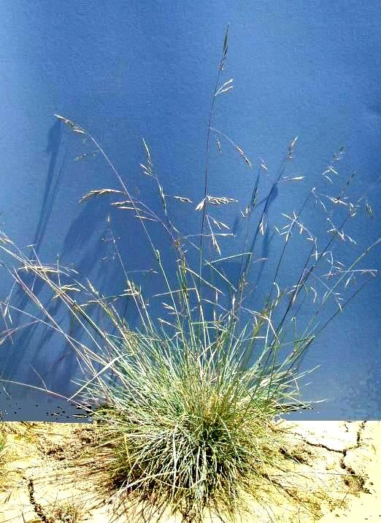
Dale Darris
USDA NRCS Corvallis PMC

Alternate names: Also known as Festuca idahoensis Elmer ssp. roemeri (Pavlic) S. Aiken. Other names include Festuca idahoensis var. roemeri, Festuca roemeri var. roemeri or northern Roemer’s fescue, and Festuca roemeri var. klamathensis or southern Roemer’s fescue.

Uses: Roemer’s fescue is an important native grass for restoration of upland prairie and oak savanna within its natural range of western Oregon, western Washington, and northwest California. While uncommon or even rare due to habitat loss, it is still dominant in some remnant prairies. Typically found on steep, shallow, or highly mineral soils, it may also be useful for revegetation and erosion control where a slower establishing, fine textured native grass is desired. Although Roemer’s fescue does not compete well with introduced grasses, it is drought tolerant and its non-aggressive growth habit suggests compatibility with forbs. Other possible uses are low maintenance lawns or as a cover crop in vineyards and young orchards, although further evaluation is needed. Some populations and specimens have ornamental value, including those with fine textured, purple and red tinged stems or bluish foliage. Forage value and palatability for wildlife and livestock are unknown, but may be similar to Idaho fescue (F. idahoensis). As a range grass, Idaho fescue is rated as fair to good forage.

Description: Roemer’s fescue is a native cool season perennial bunchgrass with variable longevity and mostly basal foliage. It is short, fine textured, and densely tufted, and has stiff culms that grow 35-100 cm tall. The panicle (seed head) is open and 5-20 cm long. Leaves are often glaucous (covered with a whitish waxy coating) and color varies throughout a wide spectrum of greens and blues. Stem color ranges from light green to dark purple or red.

Key to identification: Proper identification takes experience. Refer to "Fescues and Allies of Western Oregon" by B. Wilson (Institute for Applied Ecology, Corvallis, OR, 2002) for details with an excerpt as follows: "The less blue individuals are easily confused with chewings red fescue (Festuca rubra var. commutata), which is widely naturalized. When the two grow together, Roemer’s fescue lives in drier or less disturbed microhabitats. It is very easily confused with sheep and hard fescues. Sterile individuals are indistinguishable or identifiable only by leaf anatomy. However, fertile F. roemeri has a much more open inflorescence and longer lemmas than any sheep or hard fescue. Occasionally confused with sterile Stipa lemmonii (Lemmon’s needlegrass), but Roemer’s fescue does not live on the xeric soils preferred by S. lemmonii."

Adaptation: Roemer’s fescue is a mid to late succession species in its natural habitat. It prefers moderately acid to slightly alkaline, fine to medium textured mineral soils. The species generally grows in full sun but will tolerate partial shade near forest edges and oaks. While drought tolerant with extensive roots, it is found on somewhat more mesic (moist) sites such as the edges of grassy balds. As an upland grass it requires good soil drainage and does not tolerate winter soil saturation or flooding.

Roemer’s fescue is only found west of the Cascade and northern Sierra Nevada Mountain Ranges. Variety roemeri occurs from Douglas County and northeast Jackson County, Oregon, north to British Columbia and south along the Pacific coast to San Francisco. The species occurs on moderately dry to moist prairies, savannas, meadows, and grassy openings within woods. Variety klamathensis occurs in similar habitats, but also on serpentine substrates (soils toxic to many plants due to high levels of magnesium and iron silicates and other minerals). It is not found along the coast. The species intergrades with Idaho fescue (Festuca idahoensis) in southwest Oregon.

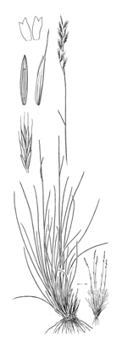

Reprinted with permission, University of Washington Press

Commercial availability: One or more populations are available for western Oregon.

Relative abundance in the wild: Roemer’s fescue is scarce from the Willamette Valley of Oregon north to British Columbia. It is scattered to uncommon from Eugene, Oregon south to San Francisco.

Limitations or environmental concerns: There is potential for poor seed fill in some populations, possibly from inbreeding depression or other factors. It is susceptible to stem and leaf rust which can severely weaken plants in some years. Misidentification between Roemer’s fescue and introduced red fescue (Festuca rubra) may lead to contamination of seed fields and restoration sites.

Establishment: Seeds germinate without treatment. However, germination is quicker and more uniform after 14 days of cold, moist stratification (chilling). There are approximately 500,000 seeds/lb with hulls intact. A seeding rate of 1 lb/ac results in about 12 seeds/sq. ft. Sown alone, recommended rates vary from 4 to 20 pure live seed (PLS) lbs/ac depending on goals. Fall seeding is generally preferred but not required. Rate of establishment from seed is moderately slow. Spring sown plants do not flower until the second full growing season. This species is presumed to be well adapted to fire as a natural feature of prairie ecosystems. It may possess management requirements similar to Idaho fescue such as deferred grazing every few years, but verification is needed.

Prepared By:
Dale Darris, Sonja Johnson, and Amy Bartow. USDA NRCS Plant Materials Center, Corvallis, Oregon.

Species Coordinator:
Dale Darris, USDA NRCS Plant Materials Center, Corvallis, Oregon.

Edited 7/31/07 D. Darris; 070801 jsp

For more information about this and other plants, please contact your local NRCS field office or Conservation District, and visit the PLANTS Web site<http://plants.usda.gov> or the Plant Materials Program Web site <http://Plant-Materials.nrcs.usda.gov>

The U.S. Department of Agriculture (USDA) prohibits discrimination in all its programs and activities on the basis of race, color, national origin, sex, religion, age, disability, political beliefs, sexual orientation, and marital or family status. (Not all prohibited bases apply to all programs.) Persons with disabilities who require alternative means for communication of program information (Braille, large print, audiotape, etc.) should contact USDA's TARGET Center at 202-720-2600 (voice and TDD).
To file a complaint of discrimination write USDA, Director, Office of Civil Rights, Room 326-W, Whitten Building, 14th and Independence Avenue, SW, Washington, DC 20250-9410 or call 202-720-5964 (voice or TDD). USDA is an equal opportunity provider and employer.
Read about Civil Rights at the Natural Resources Conservation Service.

